APPLECROSS SENIOR HIGH SCHOOL
Human Biology Unit 3
TEST 2: NERVOUS SYSTEM

DO NOT MARK THIS PAPER IN ANY WAY

Time Allowed: All Period

PART A. Answer questions 1 to 30 on the multiple choice answer sheet provided by marking the letter corresponding to the BEST alternative

- The part of the nervous system which produces the “fight or flight” response is the
a) central nervous system
b) parasympathetic system
c) peripheral nervous system
d) sympathetic system
- Which of the following symptoms would a person with a degenerative disease of the cerebellum be most likely to show?
a) Loss of peripheral vision
b) Reduced motor co-ordination
c) Difficulty hearing high pitched sounds
d) Loss of long term memory
- The regulation of breathing and heart rate involves neurons cell bodies that lie in the:
a) cerebrum
b) spinal cord
c) medulla
d) thalamus
4. The following is a list of structures in the body that may detect stimuli.
i. semicircular canals of the inner ear
ii. stretch receptors in the joints
iii. retina of the eyes
iv. baroreceptors in blood vessels
v. pain receptors in the skin
vi. pressure receptors in the skin

Which of these structures send information to the brain to assist in the maintenance of
balance and posture?
a) i, ii, iii and vi
b) i, ii, iv and vi
c) ii, iv and v
d) i, iii, iv and v

5. A student completing an examination experienced the following sequence of events:
i. he opened the first page of his examination paper
ii. his heart rate began to increase rapidly
iii. he began to write his first answers
iv. his heart rate decreased back to normal levels

Which of the following correctly links the events above to the branches of the nervous system that control them?

 | i | ii | iii | iv
a) | somatic | sympathetic | somatic | parasympathetic
b) | somatic | parasympathetic | somatic | sympathetic
c) | sympathetic | somatic | parasympathetic | somatic
d) | parasympathetic | somatic | sympathetic | somatic

6. A sensory neuron has its cell body located in:

a) gray matter of the spinal cord.
b) gray matter of the cerebrum.
c) white matter of the spinal cord.
d) a dorsal root ganglion.

7. A nerve fibre is a:

a) | bundle of axons.
b) | bundle of dendrites.
c) | motor nerve.
d) | cytoplasmic extension of a nerve cell body.

8. Consider the section of the brain illustrated below:
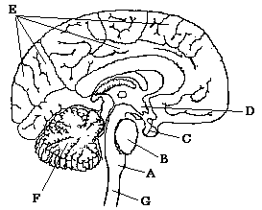

Which of the following is CORRECT?

a) D is the hypothalamus, F is the cerebral cortex and G is the spinal cord.
b) A is the medulla, B is the pons and F is the cerebellum.
c) B is the hypothalamus, C is the pituitary gland and E is the cerebrum.
d) C is the hypothalamus, F is the cerebellum and G is the spinal cord.

9. Conscious control of muscular activity is carried out by the:

a) | cerebrum.
b) | cerebellum.
c) | medulla oblongata.
d) | skeletal muscles.

10. The autonomic nervous system is responsible for:
a) higher brain functions
b) co-ordination of muscular activity
c) involuntary control of our internal environment
d) voluntary control of respiration
11. Which of the structures labelled on the diagram below is responsible for conducting nervous impulses away from the cell body?
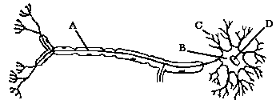
a) | A
b) | B
c) | C
d) | D

12. Which of the following statements BEST describes homeostasis?

a) Homeostasis maintains the core body temperature at a constant level.
b) Homeostatic mechanisms make the body relatively independent of external changes.
c) Thirst and hunger are homeostatic mechanisms.
d) Homeostasis ensures that cells always function at their optimum level.

13. Which of the following is the correct sequence of events (and structures) that are involved in a steady state control system?

a) Stimulus → effector → receptor → modulator → response → feedback
b) Stimulus → receptor → modulator → effector → response → feedback
c) Stimulus → response → receptor → modulator → effector → feedback
d) Feedback → stimulus → effector → modulator → receptor → response

14. Receptors are:

a) nerve centres in the spinal cord.
b) centres in the brain that receive nerve impulses.
c) specialised nervous tissue sensitive to changes in our surroundings.
d) nerves that conduct impulses within the central nervous system.

15. Myelination of a nerve fibre

a) causes a slower conduction of nerve impulses along the fibre.
b) prevents the nerve impulses from jumping along the fibre.
c) slows the fibre’s return to normal following conduction of an impulse.
d) speeds up the passage of nerve impulses along the fibre.

16. The point where a nervous impulse is transferred from a neuron to a muscle fibre is called the

a) synapse.
b) neurotransmitter.
c) Nodes of Ranvier
d) interneuron.

17. What are the correct labels for the boxes labelled (A) and (B)?

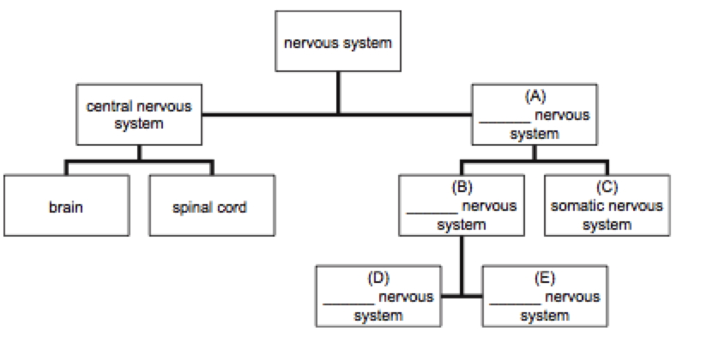

a) sympathetic; parasympathetic
b) peripheral; autonomic
c) sympathetic; peripheral
d) parasympathetic; autonomic

18. The cerebral cortex

a) acts as a protective layer covering the brain.
b) connects the right hemisphere with the left hemisphere.
c) is responsible for voluntary muscle movements.
d) increases the strength of the immune system.

19. Which of the following statements about neurons is correct?

a) afferent neurons make the connection between motor and sensory neurons
b) efferent neurons make the connection between motor and sensory neurons
c) afferent neurons carry information from the sensory organs to the central nervous system
d) efferent neurons carry information from the sensory organs to the central nervous system

20. A spinal reflex is a

a) voluntary, stereotyped response to change.
b) protective, acquired behaviour.
c) rapid, involuntary response to a stimulus.
d) spontaneous response along a complex neural pathway.

21. When the sympathetic nervous system is activated, which of the following changes occur in the body?

a) the blood pressure decreases and the pupils dilate
b) the blood pressure increases and the pupils dilate
c) the blood pressure decreases and the pupils contract
d) the blood pressure increases and the pupils contract

22. Many nerve fibres consist of an axon and its myelin sheath. This myelin sheath:

a) | is responsible for the colour of the gray matter in the brain and spinal cord.
b) | is produced by Schwann cells located along the axon.
c) | is continuous all the way along the axon.
d) | all of the above.

23. Which of the following statements about the autonomic nervous system is correct? The autonomic nervous system:

a) affects the contraction rate of skeletal muscles.
b) affects the contraction rate of non-skeletal muscles.
c) is required to begin each contraction in skeletal muscles.
d) is required to begin each contraction in non-skeletal muscles.

24. Which of the following statements regarding membrane potentials is true?

a) An action potential is a brief reversal of charge across a cell membrane.
b) In a resting membrane potential the outside of the membrane is negatively charged compared to the inside.
c) Stimulation of a cell membrane results in sodium ion movement out of the cell.
d) all of the above

25. Given the following events:

1. acetylcholine broken down
2. acetylcholine moves across the synaptic cleft
3. action potential reaches the terminal branch (presynaptic terminal) of a motor neuron
4. acetylcholine combines with a receptor molecule on a skeletal muscle (postsynaptic membrane)
5. action potential produced in skeletal muscle cell

Choose the arrangement that lists the events in the order they occur at a neuromuscular junction.

a) 2, 3, 4, 1, 5
b) 3, 2, 4, 5, 1
c) 3, 4, 2, 1, 5
d) 4, 5, 2, 1, 3

Questions 26 ,27 and 28 refer to the diagram below.

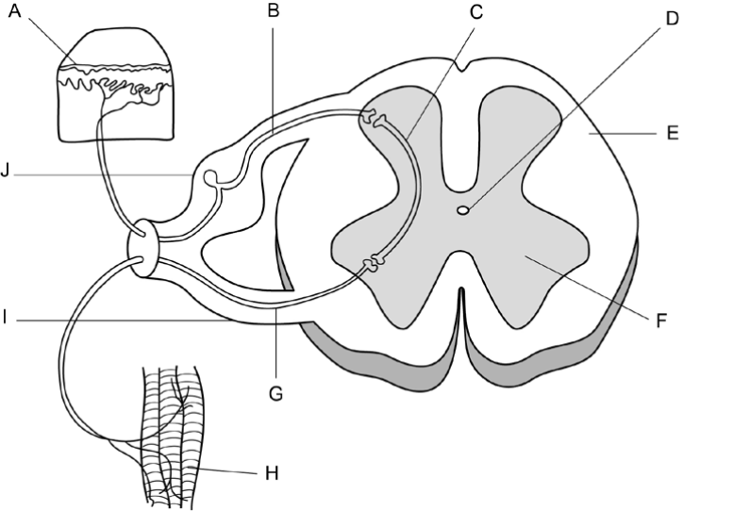

26. Which of the following statements is correct?

a) A stimulus is detected by the receptors labelled ‘H’ and transmitted through the
sensory neuron labelled ‘G’.
b) The motor neuron is labelled ‘G’ and is located in the ventral root labelled ‘I’.
c) The interneuron is labelled ‘C’ and is located in the white matter labelled ‘F’.
d) A stimulus is detected by the receptors labelled ‘A’ and transmitted through the
motor neuron labelled ‘B’.

27. The neuron labelled ‘B’ in the diagram can be described as an
a) afferent neuron carrying information toward the spinal cord.
b) efferent neuron carrying information away from the spinal cord.
c) efferent neuron carrying information toward the spinal cord.
d) afferent neuron carrying information away from the spinal cord.

28. Structure D:

a) | contains blood vessels. |  | .
b) | contains nerves
c) | contains fluid.
d) | makes the spinal cord flexible.

Use the simplified diagram below of the nerve supply to a toe to answer questions 29 and 30

Lines A, B, C, and D show regions of the nervous system which might be blocked.
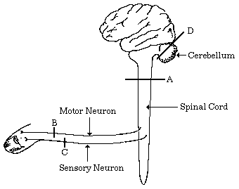

29. If the skin over the toe is stimulated and the stimulus can be felt but the toe cannot be moved then the block is at:

a) | A.
b) | B.
c) | C.
d) | D.
30. If the toe is stimulated it moves, but neither this movement nor the stimulation can be felt, then the block is at:

a) | A.
b) | B.
c) | C.
d) | D.

APPLECROSS SENIOR HIGH SCHOOL
Human Biology Unit 3
TEST 2: NERVOUS SYSTEM

Name: ________________________________ Score: ______/30

PART B: SHORT ANSWER

1.
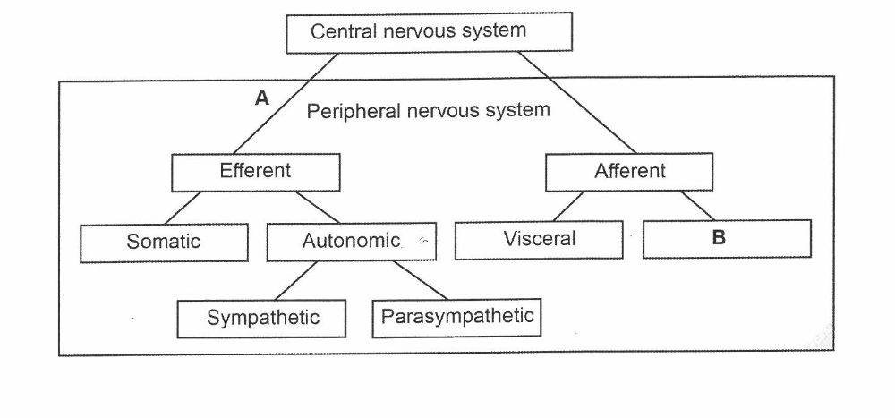
Using the diagram above, complete the following:

a) On the diagram above, draw the head of an arrow on the line labeled ‘A’ to show the direction of impulses between the central and peripheral nervous systems. (1 mark)

b) Where is information communicated to or from by the division shown as ‘B’ in the diagram. (1 mark)

______________________________________________________________________________
Somatic / muscles and skin
______________________________________________________________________________

c) A medical condition called hyperhidrosis is caused by an over-activity of neurons sending impulses to the sweat glands. Symptoms of the condition are normally seen when a person feels nervous or stressed.
Which division of the peripheral nervous system would be affected in this situation? Explain why you have chosen this division. (2 marks)

______________________________________________________________________________
Sympathetic NS (1)
This occurs in a time when the body is in the “fight or flight” / excited state. (1)
______________________________________________________________________________

______________________________________________________________________________

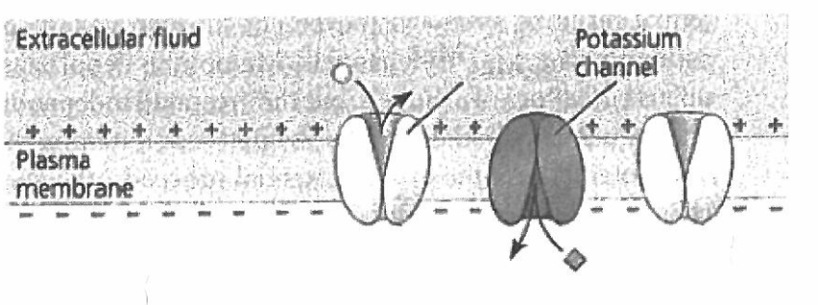
2. Diagram 1
A

The diagram above represents an axon of a nerve cell membrane prior to an action potential occurring.

(a) What substance would be able to pass through structure A when an action potential occurs? (1 mark)

Sodium ion
______________________________________________________________________________

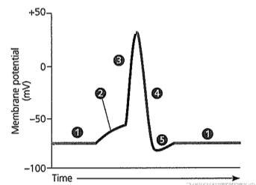
Diagram 2
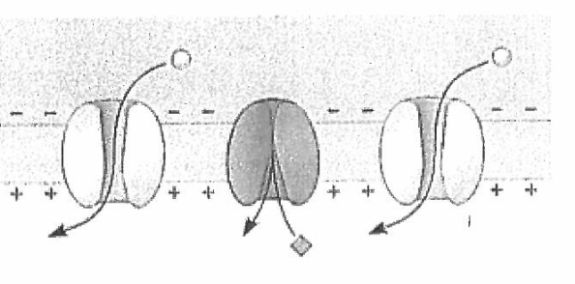

(b) (i) Which part/s of the action potential shown in the graph above (1, 2, 3, 4, or 5) would Diagram 2 depict? (1 mark)2

2 and 3
______________________________________________________________________________

(ii) What is this called? (1 mark)

depolarisation
______________________________________________________________________________

(iii) Explain the difference between parts 2 and 3 on the graph above. (2 marks)

Part 2 is before threshold and part 3 is after threshold has been reached (1)

Part 2 has not had a strong enough impulse/enough sodium channels open/ sodium is trickling inPart 3 all sodium channels are open/ sodium is flooding in (1)

(c) Explain how a sodium potassium pump maintains the level of ions required for a resting nerve cell membrane. (2 marks)

3 sodium ions move out of the cell and 2 potassium move in (1)

This makes the outside more positive than the inside for a resting potential (1)

(d) Ouabain is a substance extracted from an African plant by the Somali people who use it to poison their arrow-heads in order to kill animals. A sufficient concentration of the chemical can bring down a hippopotamus. Scientists now know that ouabain prevents the sodium-potassium pumps in nerve cell membranes from working. What effect would this have on the action potential and why? (2 marks)

Resting potential could not be restored (1)
No further action potential could be initiated (1)

(e) State two (2) ways in which the speed of action potentials can be increased.
(2 marks)

Thicker axons
Shorter axons
Myelination
Greater concentration gradient across the membrane (any 2)

3. Describe two structural and one functional difference between a sensory and connector neuron.
(3 marks)

 | Sensory Neuron | Connector Neuron
Structural | .Myelinated  Long axons  Join to receptors  Nucleus on side of axon | Unmyelinated  Short axons  Join to other neurons  Nucleus at end of axon
Functional | Takes impulse from receptor to CNS | Takes impulse from sensory neuron to motor neuron

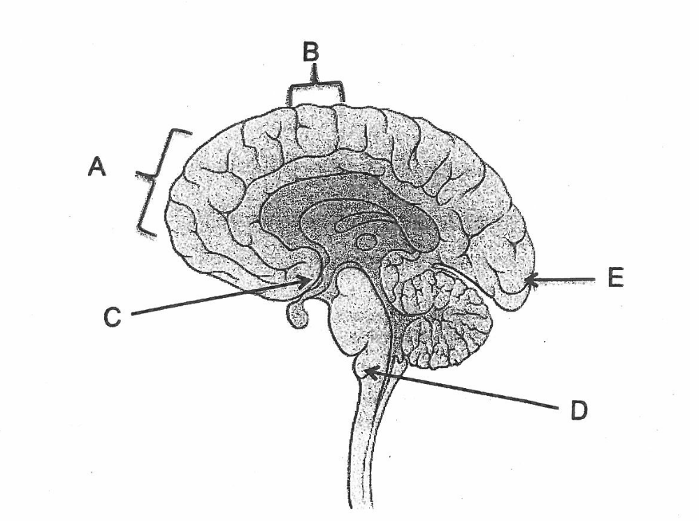
4. This question refers to the diagram below.

a) Describe the role of the structures labelled A and B in the control of body movement.
Structure A:
Association area for movement
Processing of impulses for movement (1/2 each)

Structure B:
Primary motor cortex
Motor neurons leave to go to effectors (1/2 each) (2 marks)
b) If an injury occurred in the area E, what sense would be likely to be affected?
vision (1 mark)
c) What lobe of the brain is represented by structures:
(i) A Frontal Lobe
______________________________________________________________________________
(1 mark)
(ii) E Occipital Lobe
______________________________________________________________________________
(1 mark)

PART C: EXTENDED ANSWER (7 marks)

The sympathetic and parasympathetic divisions of the autonomic nervous system are said to be “antagonistic” in their effects. Explain this statement using the heart, small intestine and blood vessels as examples.

Antagonistic means opposite

S heightens functions ready for the fight or flight response:
P calms or inhibits for the rest and digest response. (1)
Sympathetic NS causes the heart to beat faster to provide food and oxygen to the cells. (1)
During times of rest Parasympathetic slows the heart. (1)

SNS causes the blood vessels of the muscles dilate to provide food and oxygen for contraction. (1)
PNS dilates the blood vessels of the digestive system during rest to enable food to be absorbed. (1)

SNS slows peristalsis / the muscles of the small intestine to divert energy to other areas (muscles) (1)
PSN increases peristalsis to promote digestion during rest (1)

